CS 255 System Design Document

UML Diagrams

UML Use Case Diagram
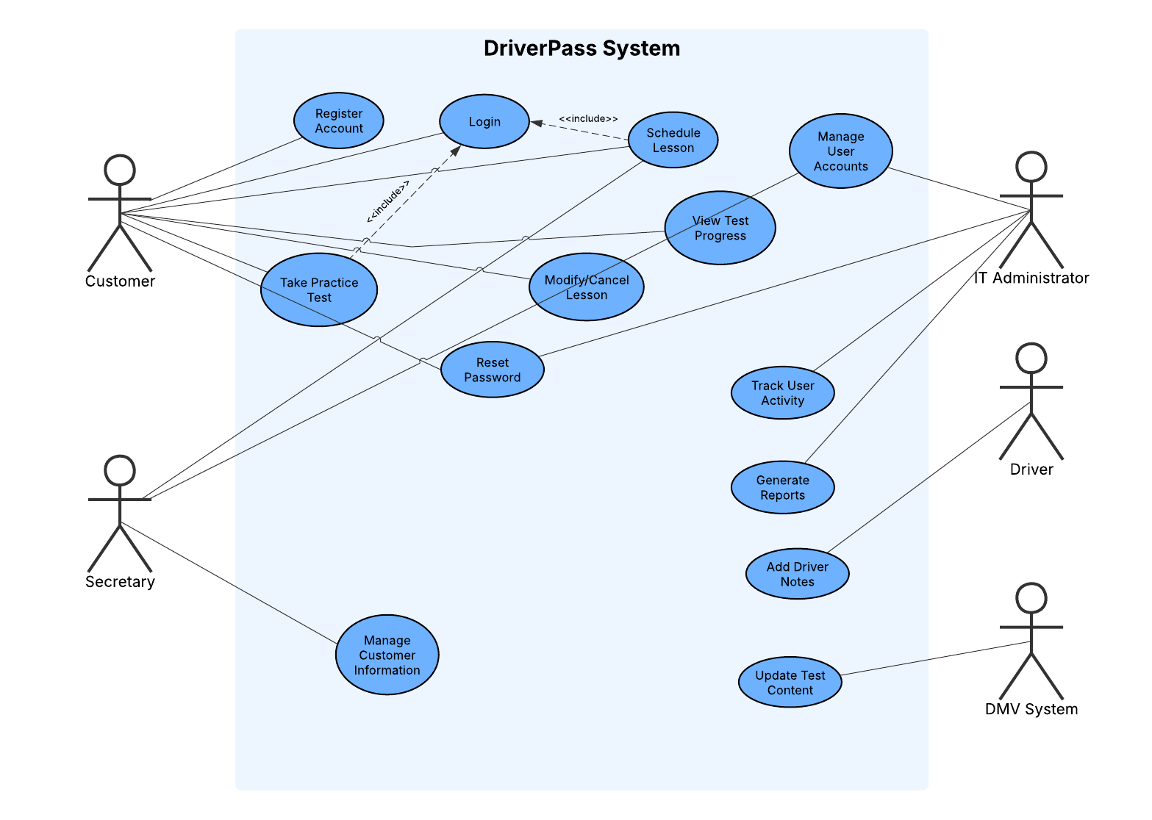The UML use case diagram illustrates how different users interact with the DriverPass system. The primary actors include the customer, secretary, IT administrator, driver, and DMV system. Customers can register accounts, log in, schedule driving lessons, take practice tests, and view their progress. Secretaries assist with scheduling and managing customer information, while administrators manage users, system activity, and reports. Drivers can log lesson notes, and the DMV system provides updated test content. This diagram ensures that all user interactions and system functionalities are clearly defined and aligned with DriverPass requirements.

UML Activity Diagrams
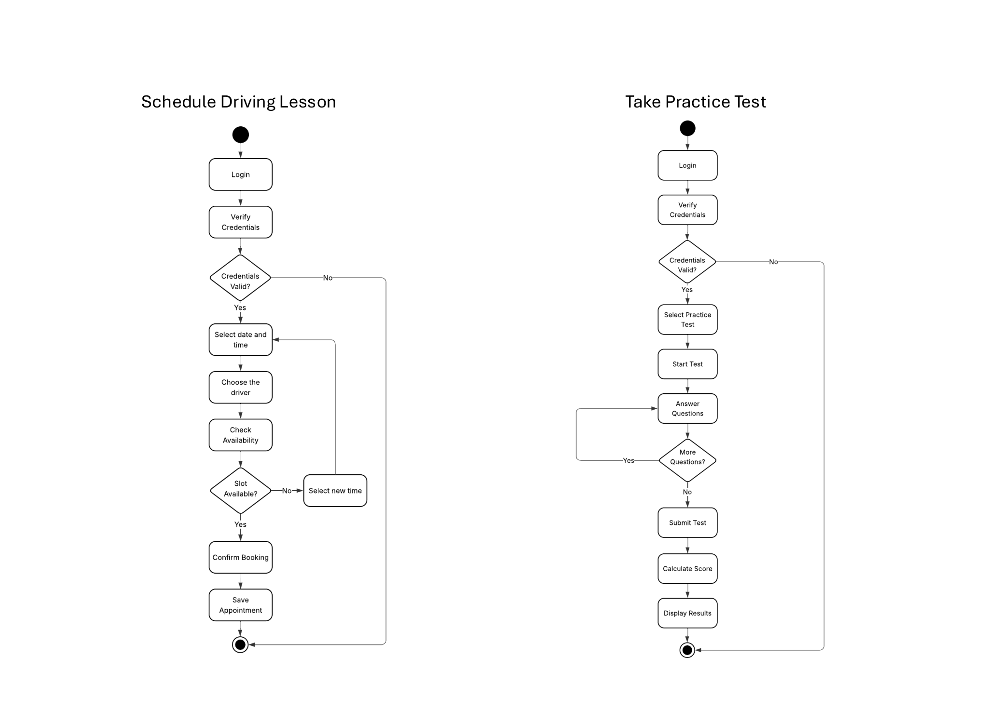
The activity diagrams show the step-by-step workflows of two key system processes. The first diagram represents scheduling a driving lesson, where the user logs in, selects a date and time, chooses a driver, and confirms the booking. A decision point ensures that the selected time slot is available before confirming the appointment. The second diagram represents taking a practice test, where the user logs in, selects a test, answers questions, submits the test, and receives a score. These diagrams help visualize the flow of actions and decision points within the system.

UML Sequence Diagram
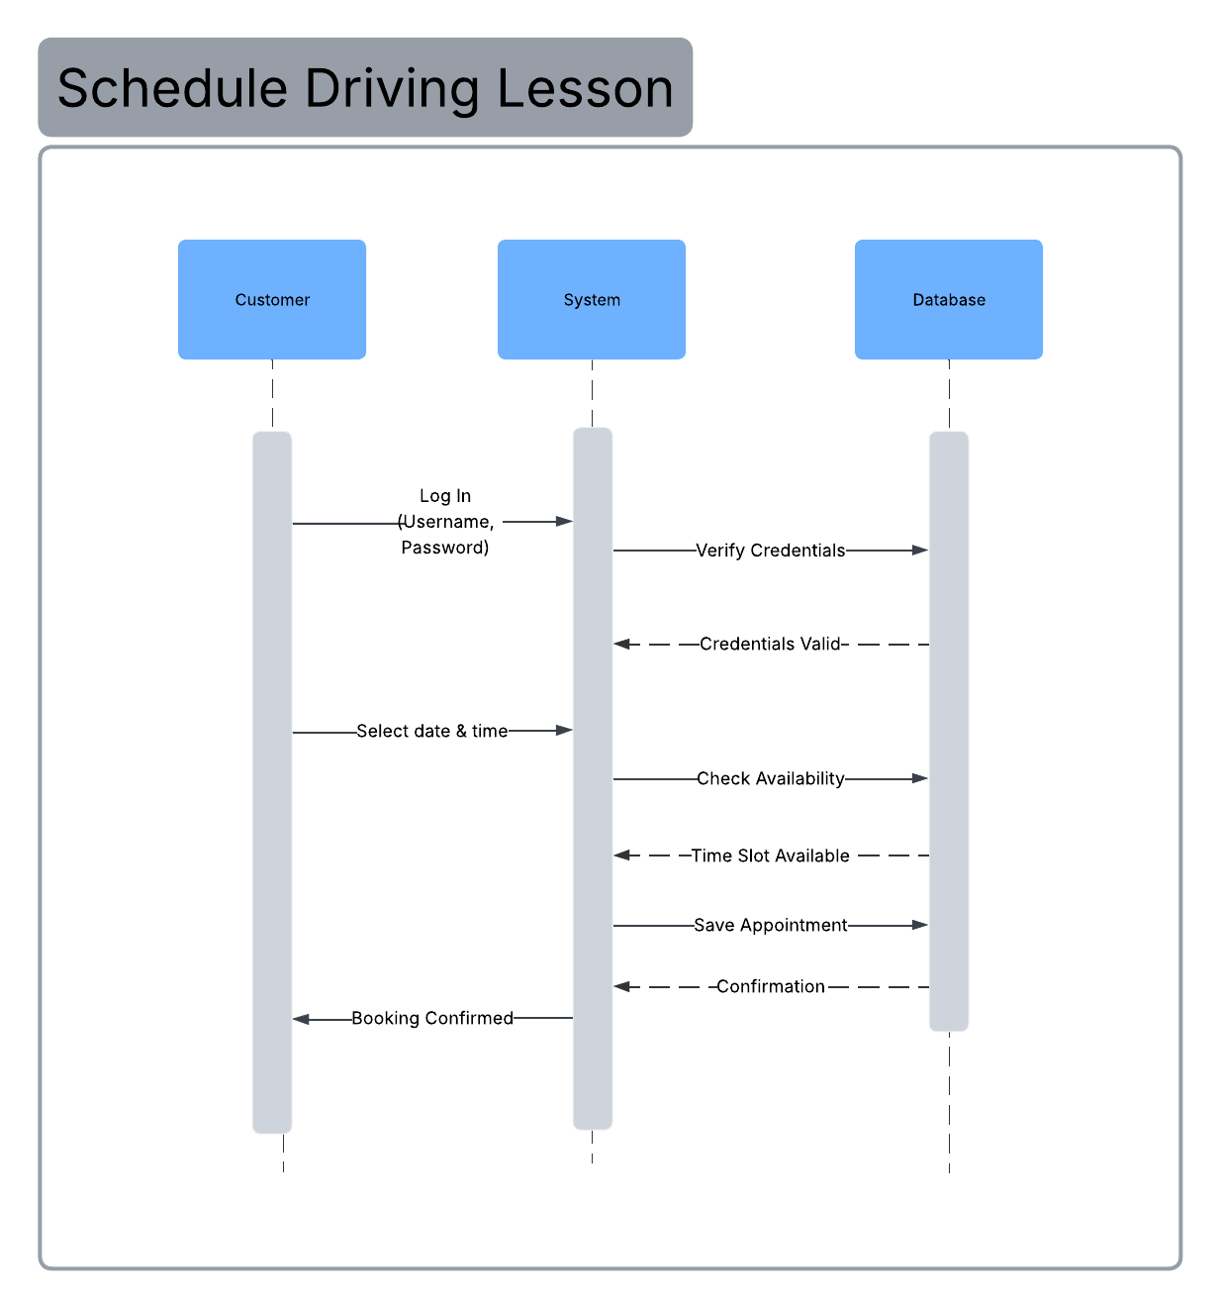
The sequence diagram shows how different system components interact during the scheduling of a driving lesson. The customer sends a request to log in, and the system verifies the credentials with the database. The customer then selects a time slot, and the system checks availability through the database. Once availability is confirmed, the system saves the appointment and sends a confirmation back to the customer. This diagram highlights the order of interactions and communication between system components.

UML Class Diagram
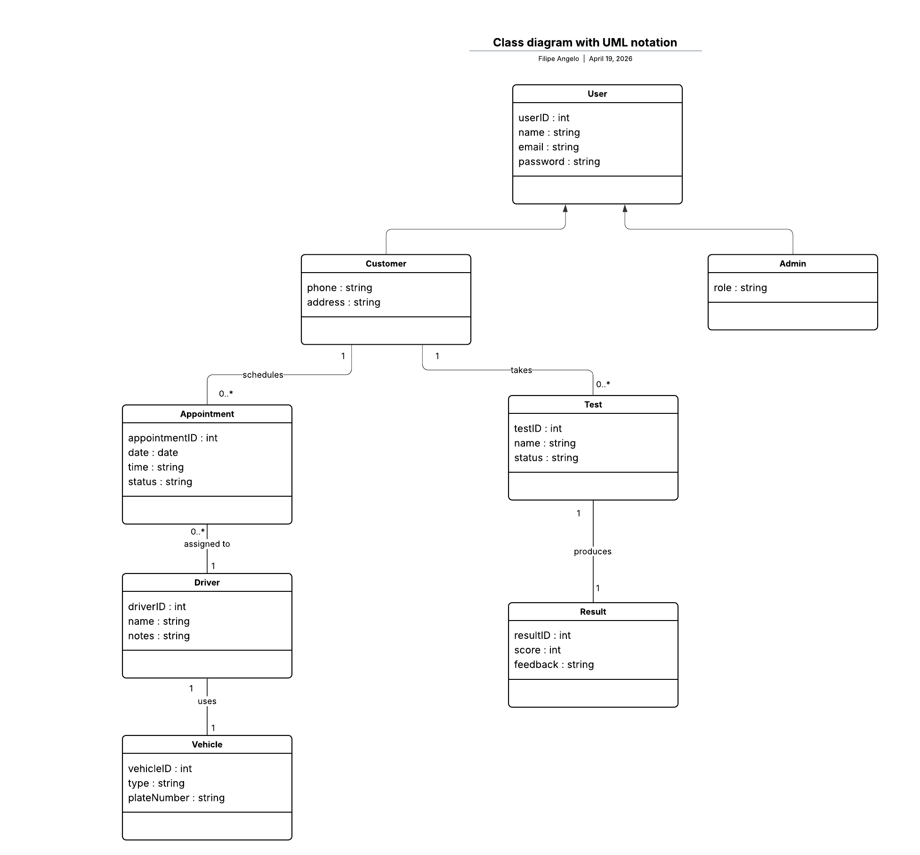
The class diagram represents the structure of the DriverPass system by defining its main classes and their relationships. The system includes classes such as User, Customer, Admin, Driver, Appointment, Test, Result, and Vehicle. Each class contains attributes that define its data, such as user ID, appointment time, or test score. Relationships between classes show how different parts of the system are connected, such as customers having multiple appointments and tests. This diagram provides a clear view of how data is organized within the system.

Technical Requirements
The DriverPass system will be a web-based application accessible on both desktop and mobile devices. The system will run on servers equipped with Intel Xeon or AMD equivalent processors, with 16–32 GB of RAM and at least 1TB of SSD storage to ensure efficient performance and data handling.

The system will use operating systems such as Windows Server or Linux and will be developed using backend technologies like Node.js or Java. A relational database system such as MySQL or PostgreSQL will be used to store user accounts, appointments, test results, and system activity data.

The system will be hosted using cloud services such as AWS or Microsoft Azure to ensure scalability and availability. Version control tools like GitHub will be used to manage system updates and development. Security will be implemented using encrypted connections (SSL) and secure authentication methods to protect user data.

The infrastructure will require a high-speed internet connection of at least 1 Gbps to support system performance and multiple users. The system will include secure authentication, role-based access control, and backup systems to ensure data protection and system reliability.

